HIGH ERCALL PRIMARY SCHOOL

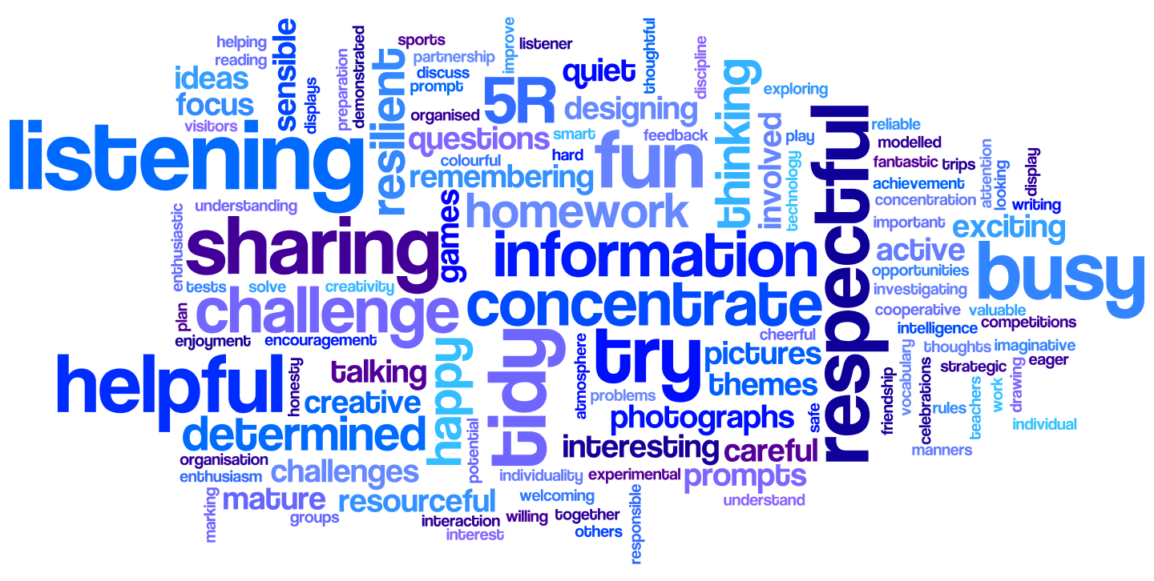

Privacy Notice
Policy- Document Status
Date of Policy Creation | 21st May 2018 | Named Responsibility
Date of review completion | 13th June 2018 | Named  Responsibility | Sarah Roberts
Date of Policy Adoption by Governing Body (HASAS committee) |  | 13th June 2018

Privacy Notice (How we use pupil information)

At High Ercall Primary School, we collect and use pupil information under section 537A of the Education Act 1996, and section 83 of the Children Act 1989. We also comply with Article 6(1) (c) and Article 9 (2) (c) (g) of the General Data Protection Regulation (GDPR).

The categories of pupil information that we process include:

- personal identifiers and contacts (such as name, photograph, unique pupil number, contact details and address)
- characteristics (such as ethnicity, language, and free school meal eligibility)
- safeguarding information (such as court orders and professional involvement)
- special educational needs (including the needs and ranking)
- medical and administration (such as doctors information, child health, dental health, allergies, medication and dietary requirements)
- attendance (such as sessions attended, number of absences, absence reasons and any previous schools attended)
- assessment and attainment (such as key stage 1 and phonics results, internal data and key stage 2 SAT results)
- behavioural information (such as exclusions and any relevant alternative provision put in place)

This list is not exhaustive, to access the current list of categories of information we process please see our school website.
Why we collect and use pupil information

We collect and use pupil information, for the following purposes:
- to support pupil learning
- to monitor and report on pupil attainment progress
- to provide appropriate pastoral care
- to assess the quality of our services
- to keep children safe (food allergies, medical information or emergency contact details)
- to meet the statutory duties placed upon us for DfE data collections
- to share aspects of learning with stakeholders

Under the General Data Protection Regulation (GDPR), the main lawful bases we rely on for processing pupil information are:

Article 6
Condition 1(a) where you provide consent for example to use student images
Condition 1(b) to enable us to complete a service you have asked for
Condition 1 (c) to comply with our legislative requirements including:
o Section 537A of the Education Act 1996
o the Education Act 1996 s29(3)
o the Education (School Performance Information)(England) Regulations 2007
o regulations 5 and 8 School Information (England) Regulations 2008
o the Education (Pupil Registration) (England) (Amendment) Regulations 2013

Condition 1(d) to protect the vital interests of students and parents by processing relevant medical information
Article (9) for Special Category Information:
Condition 2(a) - Explicit consent has been given
Condition 2 (c) – Protect the vital interests of a student
Condition 2 (g) – Necessary for reasons of substantial public interest

When collecting personal data we will provide the legal basis upon which the processing is based at the point of collection.

How we collect pupil information
We obtain pupil information via registration forms at the start of each academic year. In addition, when a child joins us from another school we are sent a secure file containing relevant information.

Pupil data is essential for the schools’ operational use. Whilst the majority of pupil information you provide to us is mandatory, some of it requested on a voluntary basis. In order to comply with the data protection legislation, we will inform you at the point of collection, whether you are required to provide certain pupil information to us or if you have a choice in this.

How we store pupil data
We hold pupil data securely for the set amount of time shown in our data retention schedule. For more information on our data retention schedule and how we keep your data safe, please visit our school website.

Who we share pupil information with
We routinely share pupil information with:

- schools that the pupils attend after leaving us
- our local authority
- the Department for Education (DfE)

Why we regularly share pupil information
We do not share information about our pupils with anyone without consent unless the law and our policies allow us to do so.

Department for Education
The Department for Education (DfE) collects personal data from educational settings and local authorities via various statutory data collections. We are required to share information about our pupils with the Department for Education (DfE) either directly or via our local authority for the purpose of those data collections, under:
• Section 537A of the Education Act 1996
• the Education Act 1996 s29(3)
• the Education (School Performance Information)(England) Regulations 2007
• regulations 5 and 8 School Information (England) Regulations 2008
• the Education (Pupil Registration) (England) (Amendment) Regulations 2013
All data is transferred securely and held by DfE under a combination of software and hardware controls, which meet the current government security policy framework.
For more information, please see ‘How Government uses your data’ section.

Requesting access to your personal data
Under data protection legislation, parents and pupils have the right to request access to information about them that we hold. To make a request for your personal information, or be given access to your child’s educational record, contact the headteacher, Mrs Sarah Roberts, or administrator, Mrs Mavis Whiteley.

You also have the right to:
- object to processing of personal data that is likely to cause, or is causing, damage or distress
- prevent processing for the purpose of direct marketing
- object to decisions being taken by automated means
- in certain circumstances, have inaccurate personal data rectified, blocked, erased or destroyed; and
- a right to seek redress, either through the ICO, or through the courts

If you have a concern or complaint about the way we are collecting or using your personal data, you should raise your concern with us in the first instance or directly to the Information Commissioner’s Office at https://ico.org.uk/concerns/

Contact

If you would like to discuss anything in this privacy notice, please contact: Mrs Roberts, Headteacher, at the school.

How Government uses your data
The pupil data that we lawfully share with the DfE through data collections:
- underpins school funding, which is calculated based upon the numbers of children and their characteristics in each school.
- informs ‘short term’ education policy monitoring and school accountability and intervention (for example, school GCSE results or Pupil Progress measures).
- supports ‘longer term’ research and monitoring of educational policy (for example how certain subject choices go on to affect education or earnings beyond school)

Data collection requirements
To find out more about the data collection requirements placed on us by the Department for Education (for example; via the school census) go to https://www.gov.uk/education/data-collection-and-censuses-for-schools

The National Pupil Database (NPD)
Much of the data about pupils in England goes on to be held in the National Pupil Database (NPD).
The NPD is owned and managed by the Department for Education and contains information about pupils in schools in England. It provides invaluable evidence on educational performance to inform independent research, as well as studies commissioned by the Department.
It is held in electronic format for statistical purposes. This information is securely collected from a range of sources including schools, local authorities and awarding bodies.
To find out more about the NPD, go to https://www.gov.uk/government/publications/national-pupil-database-user-guide-and-supporting-information

Sharing by the Department
The law allows the Department to share pupils’ personal data with certain third parties, including:
- schools
- local authorities
- researchers
- organisations connected with promoting the education or wellbeing of children in England
- other government departments and agencies
- organisations fighting or identifying crime
For more information about the Department’s NPD data sharing process, please visit:
https://www.gov.uk/data-protection-how-we-collect-and-share-research-data

Organisations fighting or identifying crime may use their legal powers to contact DfE to request access to individual level information relevant to detecting that crime. Whilst numbers fluctuate slightly over time, DfE typically supplies data on around 600 pupils per year to the Home Office and roughly 1 per year to the Police.
For information about which organisations the Department has provided pupil information, (and for which project) or to access a monthly breakdown of data share volumes with Home Office and the Police please visit the following website: https://www.gov.uk/government/publications/dfe-external-data-shares

To contact DfE: https://www.gov.uk/contact-dfe

