HIGH ERCALL PRIMARY SCHOOL

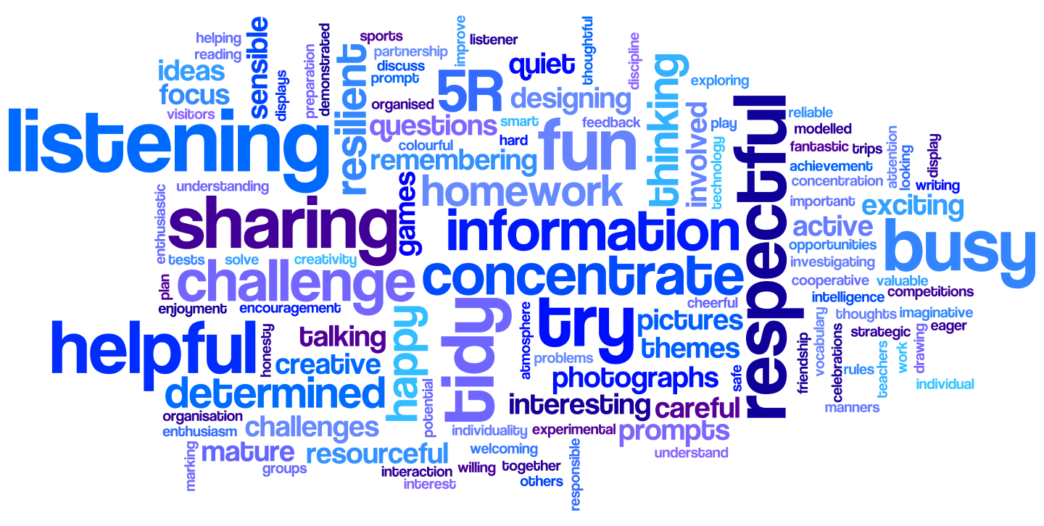

Information Sharing Policy 2020
Policy- Document Status
Date of Policy Creation | 21st May 2018 | Named Responsibility
Date of review completion | 8th September 2020 | Named  Responsibility | Sarah Roberts
Date of Policy Adoption by Governing Body (HASAS committee) |  | 12th November 2020

IS-20 |  |  |  | Information Sharing Policy (v3.0)

- Introduction & Scope of Policy

1.1 This policy is based on the requirements of the latest Information Commissioners Office (ICO) Data Sharing Code of Practice. The policy will help ensure any sharing is fair, transparent and in line with the Data Protection Act 2018 (DPA 18) and the rights and expectations of the people whose information is being shared.

- What do we mean by data/information sharing

  - Information sharing is the disclosure of data from one or more organisations to a third party organisation(s), or the sharing of information between different parts of the School.

2.2. This policy covers the sharing of personal information on a systematic and exceptional basis.

2.2.1 Systematic Information Sharing – this involves the routine sharing of the same or similar information for the same person between a set number of organisations. Sharing ordinarily takes place under the conditions of an agreed information sharing agreement.

2.2.2 Exceptional Information Sharing – these are one off adhoc decisions to share information

2.3 It is important to remember that data protection principles also apply to information shared within the School as well as sharing with external organisations.

- Information Sharing and the Law

  - The School derives its powers to share information from either Acts of Parliament or other legislation that governs the Council’s activities.

  - The first point to consider before sharing information is what legal basis is there to share information. The legal basis will ordinarily fit into one of three categories.

    - Express obligations – This is where there is an established legal requirement for the Schoolto share information. An example of this would be legislation that requires the Schoolto share information with Her Majesty’s Revenues & Customs (HMRC) for taxation purposes.

    - Express powers – The School will be given legal powers to enable the sharing of information. An example of this is the Strengthening Families programme that allows the School to share information with the Department of Work & Pensions (DWP).

    - Implied powers – Certain legislation regulates how Schoolservices are run but does not give express powers to share information. However to meet the requirements of the legislation there is implied power to share information. An example here would be the Children’s Act which requires Schools to protect children. To protect a child the School may have to share information with a number of organisations.

- Deciding on Sharing Personal Information

  - There are a number of factors to be considered before information sharing takes place. The following questions need to be considered before sharing.

4.1.1 What is sharing meant to achieve? A clear objective for sharing should be identified. This will assist in deciding on what elements of information need to be shared.

4.1.2 What information needs to be shared? Only the elements of information required to meet the objective identified should be shared. Where opinion is being shared it should be clearly denoted that this is an opinion being shared.

4.1.3 Who requires access to the shared information? ‘Need to know’ principles should be applied. Individuals should only be able to access shared information if they need to.

4.1.4 When should it be shared? It should be recorded whether the sharing was on an exception or systematic basis.

4.1.5 How should it be shared?
Externally - Information should only be shared securely, e.g. electronically using secure email or hand delivered to named individuals or sent by post (special delivery/secure courier) dependent on the level of sensitivity of the information being shared.

Internally- if sharing is electronic and to/from @telford.gov.uk or @taw.org.uk then this a secure method. However the correct recipients details should be checked before an email is sent. If hard copy information is being shared then hand delivery/collection should be considered for special category (very sensitive) personal information.

4.1.6 What are the risks in sharing and not sharing the information? A number of questions should be asked such as what is the potential benefit/harm/damage to an individual whose information may be shared, will an individual be likely to object, etc.

4.1.7 Can the objective be met without sharing the information or by anonymising it? If an objective can be met by sharing anonymised information or by not sharing personal information at all then the objective should be met in this alternative way.

4.1.8 Record what you have shared. Once you have decided there is adequate justification to share information then the actual sharing should be recorded including what information was shared, to who, when and by who.

  - Obtaining consent from individuals to share their personal information should also be factored into the decision making process for sharing information. Consent should be a positive action, specific, given freely, granular and provide an informed indication of the wishes of the individual that they agree to how their personal data will be processed.. See school Guidance Note on Consentt.

  - It is not always appropriate to obtain consent from an individual (or in fact inform them that sharing is taking place) for sharing their information. Consent is not needed for all aspects of personal information sharing. An example of this is where the School is required to provide the police with information for the prevention and detection of crime or for the protection of children/vulnerable adults. However a legal basis is always required before any sharing occurs.

- Fairness and Transparency

5.1 To share information in a fair and transparent manner, individuals should be aware of which organisations are sharing their personal data, with whom and what it is being used for. Fairness also relates to how personal information is shared in that this should happen in a reasonable way that the individual would not reasonably object to. However there are certain exceptions to this, see 4.3 above.

5.2 Fairness and transparency can be achieved by the use of privacy notices which, as a minimum, tells an individual from whom information is being collected why their information will be shared and who it is going to be shared with (either named organisations or types of organisation). See school Guidance Note on Lawful Processing of Personal Data.

- Security When Sharing Information

  - The DPA 18 requires the School to have adequate technical and organisational measures in place to protect personal information. This requirement also covers when the School shares information.

  - There are a number of security issues that should be considered in respect to shared / sharing the information.

6.2.1 Information must be shared in a secure manner, see paragraph 4.1.5 for further detail.
6.2.2 Information received from other organisations should be reviewed to ensure there are no conditions of use attached to it and it needs to be kept secure.
6.2.3 Information sent from the Schoolto other organisations should be reviewed to ensure officers understand who will access it and for what purpose.
6.2.4 More sensitive information shared should be afforded additional security.
6.2.5 The level of impact of a data breach on both the individual(s) and the Council

6.3 For more information on required security arrangements please read the schools Information Security Policy.

- Governance Arrangements

  - Responsibility for sharing information lies with the ‘Information Asset Owner’. The Information Asset Owner is the Head Teacher.

7.2 The information owner should ensure there are appropriate arrangements in place to share information that comply with the requirements of this policy.

7.3 A further element of governance in respect to information sharing is the use of information sharing agreements (ISA’s). An information sharing agreement sets out a number of common rules to be adopted by the various organisations involved in the data sharing operation.

7.4 It is good practice to have an ISA in place if information sharing is taking place on a large scale or on a regular basis. The checklist for the contents of an ISA should be adhered to when drafting an ISA, the checklist can be found in the school office.

- Reporting Security Incidents

8.1 If the information shared is compromised, e.g. sent to an incorrect recipient, viewed by an unauthorised individual, etc. the schools Information Security Breach Procedure (ISBP) should be instigated immediately.

8.2 As per the ISBP procedure, all potential information security incidents should, as a minimum, be reported to the Head Teacher and the DPO.

- Contacts and Further Information

9.1 Appendix 1 provides 5 steps to effective data sharing. This can be used as a reference when considering sharing information.

5 Steps to Effective Data Sharing

What information should I share?
How should the information be shared?
Record your decision
Do you have the power to share?
Is sharing justified?
Do you think you should share?
What are the risks of sharing or not sharing?
Is an individual at risk of harm?
Is there a DPA exemption allowing me to share?
Is there legislation that allows you to share?
What is the nature of information, e.g. was it given in confidence
Have you received legal instruction
to share?
Only share what is necessary
Distinguish fact from opinion
What are risks of not sharing?
Use SCS / GCSX for sharing or hand / special delivery for hard copy
Only shared with the correct individuals – check recipient details
Consider informing individual that their information has been shared
Record data sharing decision and reasoning for this
If you share record what information was shared, with who and for what purpose
Record when it was shared, justification for this and if consent obtained

Document Version Control
Version | Date | Author | Sent To | Comments
3.0 | 280820 | R Montgomery (DPO) | School | Updates from previous version

The term personal information is used to generically include personal and sensitive information

