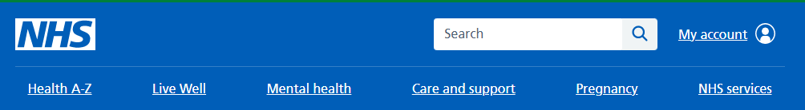

Is my child too ill for school?
It can be tricky deciding whether or not to keep your child off school, nursery or playgroup when they're unwell. There are government guidelines for schools and nurseries about managing specific infectious diseases at GOV.UK. These say when children should be kept off school and when they shouldn't. If you do keep your child at home, it's important to phone the school or nursery on the first day. Let them know that your child won't be in and give them the reason. If your child is well enough to go to school but has an infection that could be passed on, such as a cold sore or head lice, let their teacher know.
Coughs and colds - It's fine to send your child to school with a minor cough or common cold. But if they have a fever, keep them off school until the fever goes. Encourage your child to throw away any used tissues and to wash their hands regularly.
High temperature - If your child has a high temperature, keep them off school until it goes away.
Chickenpox - If your child has chickenpox, keep them off school until all the spots have crusted over. This is usually about 5 days after the spots first appeared.
Cold sores - There's no need to keep your child off school if they have a cold sore. Encourage them not to touch the blister or kiss anyone while they have the cold sore, or to share things like cups and towels.
Conjunctivitis - You don't need to keep your child away from school if they have conjunctivitis. Do get advice from your pharmacist. Encourage your child not to rub their eyes and to wash their hands regularly.
Coronavirus (COVID-19) - Your child should try to stay at home and avoid contact with other people if they have symptoms of COVID-19 and they either: have a high temperature, do not feel well enough to go to school or do their normal activities. If they have mild symptoms and they feel well enough, they can still go to school.
Ear infection - If your child has an ear infection and a high temperature or severe earache, keep them off school until they're feeling better or their high temperature goes away.
Hand, foot and mouth disease - If your child has hand, foot and mouth disease but seems well enough to go to school, there's no need to keep them off. Encourage your child to throw away any used tissues straight away and to wash their hands regularly.
Head lice and nits - There's no need to keep your child off school if they have head lice. You can treat head lice and nits without seeing a GP.
Impetigo - If your child has impetigo, they'll need treatment from a GP, often with antibiotics. Keep them off school until all the sores have crusted over and healed, or for 48 hours after they start antibiotic treatment. Encourage your child to wash their hands regularly and not to share things like towels and cups with other children at school.
Ringworm - If your child has ringworm, see your pharmacist unless it's on their scalp, in which case you should see a GP. It's fine for your child to go to school once they have started treatment.
Scarlet fever - If your child has scarlet fever, they'll need treatment with antibiotics from a GP. Otherwise they'll be infectious for 2 to 3 weeks. Your child can go back to school 24 hours after starting antibiotics.
Slapped cheek syndrome (fifth disease) - You don't need to keep your child off school if they have slapped cheek syndrome because, once the rash appears, they're no longer infectious. But let the school or teacher know if you think your child has slapped cheek syndrome.
Sore throat - You can still send your child to school if they have a sore throat. But if they also have a high temperature, they should stay at home until it goes away. A sore throat and a high temperature can be symptoms of tonsillitis.
Threadworms- You don't need to keep your child off school if they have threadworms. Speak to your pharmacist, who can recommend a treatment.
Vomiting and diarrhoea - Children with diarrhoea or vomiting should stay away from school until they have not been sick or had diarrhoea for at least 2 days (48 hours).

