High Ercall Primary School

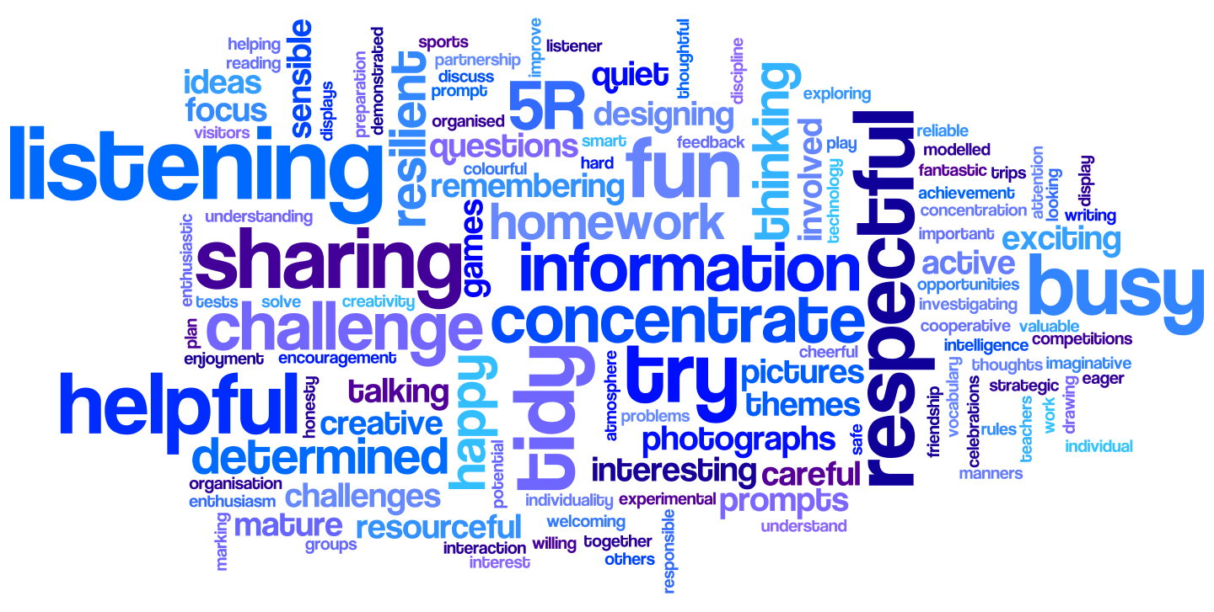

English Policy 2022

Date of Policy Creation | February 2016 | Named Responsibility | Sarah Roberts
Date of review completion | 26th January 2022 | Named  Responsibility
Inception of new Policy |  | Named  Responsibility
Policy Adoption by Governing Body |  | Curriculum Committee

See also:

Curriculum Statement for reading 2022

Curriculum Statement for writing 2022

INTRODUCTION AND SUBJECT DEFINITION
At High Ercall Primary School, we believe that literacy and communication are key life skills. Through the English curriculum, we will help children develop the skills and knowledge that will enable them to communicate effectively and creatively through spoken and written language and equip them with the skills to become lifelong learners. We want children to enjoy and appreciate literature and its rich variety.
Reading and writing are at the heart of all children’s learning. Being literate enables children both to communicate with others effectively for a variety of purposes and to examine their own and others’ experiences, feelings and ideas, giving these order and meaning. Because literacy is central to children’s intellectual, emotional and social development, it has an essential role across the curriculum and helps pupils’ learning to be coherent and progressive.
aims
- To give pupils the opportunities to interrelate the requirements of English within a broad and balanced approach to the teaching of English across the curriculum, with opportunities to consolidate and reinforce taught knowledge.
- To deliver the National Curriculum 2014 in a fun and engaging way for all children
- To provide the children with the necessary knowledge to become competent, creative and efficient users of the English language, preparing them for secondary school and to enable them to be successful in their later lives.
- To provide the children with meaningful and engaging contexts for speaking and listening, reading and writing.
- To enable all children to develop powers of imagination, inventiveness and critical awareness in all areas of literacy

curriculum organisation

The English curriculum is delivered through our Long-Term Planning for reading and writing, which was created in response to the statutory requirements of the National Curriculum 2014. Writing and reading long term planning and progression documents are in place for all year groups. This ensures appropriate coverage of both substantive and disciplinary knowledge at age related expectations. It also enables staff to be flexible and creative with their planning. Pupil provision is related to attainment, not age but most pupils should be working within the appropriate age related expectations. All staff plan on a weekly basis, using the school agreed format, in response to the needs of the children.

Reading and writing are taught in daily lessons across school. Guided and whole class reading are timetabled daily. Writing in English and across the curriculum is timetabled daily. Discrete phonics is taught in Classes 1 and 2. Spelling and grammar are taught both explicitly, and within the teaching of reading and writing. Work is differentiated in all year groups and targeted support is given to some pupils, as the need may arise.

Children work in flexible groups according to need, as identified by the class teacher. Phonics lessons are also taught in fluid, targeted groups. Children are taught in a variety of ways, either in ability groups, mixed groups or pairs depending on the task given and the focus of the lesson. Differentiation is shown on planning, and is responsive to the needs of the children.

time allocation
The following times show the general pattern of teaching, though times will be flexible each week.
Literacy – 1 hour each day
Phonics – 20 minutes each day
Reading – 20 minutes each day
Also: reading to the class, DERIC reading sessions, individual reading for targeted pupils

teaching and learning strategies
Teaching Speaking and Listening
Aims
Children need to be able to:
- Communicate effectively, speaking with increasing confidence, clarity and fluency
- Participate in discussions and debate in a variety of contexts
- Listen to the views, opinions and ideas of others with increased interest
- Articulate ideas and thoughts clearly with appropriate tone and vocabulary recognising audience
- Respond to questions and opinions appropriately
- Retell stories and poems which are known by heart
- Ask questions with increasing relevance and insight

Entitlement
Pupils have access to a wide range of speaking and listening opportunities that include:
- Talking about their own experiences, recounting events
- Participating in discussion and debate
- Talk for writing
- Retelling and reciting stories and poems
- Expressing opinions and justifying ideas
- Listening to stories read aloud
- Presenting ideas to different audiences
- Taking part in school performances
- Responding to different kinds of texts
- Talking to visitors in school
- Listening to ideas and opinions of adults and peers
- Role-play and other drama activities across the curriculum.
- Use dramatic techniques, including work in role to explore ideas and texts
- Create, share and evaluate ideas and understanding through drama

We teach speaking and listening explicitly as well as finding opportunities to reinforce and extend children’s developing skills. We embed this teaching in all subjects across the curriculum. This is particularly important as different subjects offer opportunities for different kinds of talk. This requires a discrete time allocation over the term. There should also be opportunities, both planned and incidental, for children to revisit, apply and extend. Within a unit of literacy work, speaking and listening is an intrinsic element which allows the children to explore a text type, share ideas, learn texts, perform, debate and many other skills.

Teaching Reading
Aims
To enable children to:
- develop positive attitudes towards reading so that it is a pleasurable and meaningful activity;
- apply taught word reading knowledge to be able to read with fluency, automaticity, pace and intonation
- read and respond to a variety of texts gaining the ability to interpret, deduce and comprehend a range of text types
- read widely across the curriculum, enjoying narrative texts, poetry and non-fiction in a whole range of contexts

Pupils have access to a wide range of reading opportunities that include:
- guided / whole class reading
- shared reading
- regular independent reading (DERIC – Drop Everything and Read In Class)
- home/school reading
- hearing books read aloud on a daily basis
- selecting own choice of texts including ICT texts
- reading in other subjects including ICT texts

Much of the Programme of Study will be taught through both reading and English lessons. Additional time is provided on a regular basis for reading at other times. There is time set aside for independent reading, using the library, listening to whole class stories and research linked to other subjects.
Teaching and Learning in Reading
At High Ercall, we strive to create a text rich environment for all our children, which appeals to their interests. All children are given the opportunity to read with an adult at least once a week either individually or as a group. There will also be times each day when the children hear a class book read to them by the class teacher. Some children will read to their teacher or teaching assistant more than once a week.
All children are encouraged to read at least five times each week at home – this can be their school book or a book from home. Children are rewarded in class for reading five times, and this contributes to a whole school reading reward. In Key Stage 1, we ask parents to record in the reading diary when they have read with their child. In Key Stage 2, the children are expected to complete their reading diary themselves, and there is guidance given about the expected comments to be written by the children. All children take home an individual reading book from school – one which is colour banded according to their reading level. Children in Key Stage 1 take home a book which is matched to the phonics they have been taught the previous week. They also have access to ‘Phonics Bug’, an online resource where books are selected which match taught phonics from that week, or review prior learning. Class teachers ‘release’ books each week for the children to access electronically at home each week.
Across school, the books are all colour banded according to difficulty. There is a mixture of scheme books and ‘real’ books which are used. When children become confident and fluent readers, they choose books for themselves, and are allowed to bring appropriate books from home.
Phonics is taught daily in KS1. Each child has a 20 minute taught session each day. Some children have additional catch-up sessions in the afternoon to boost progress if needed. As a school we use Phonics bug, a Pearson scheme. The children are taught new phonemes progressively, whilst recapping prior learning and other phonemes within the phase. The children are given reading books which match the phoneme taught – both as paper books and online material through Phonics Bug.
Guided reading lessons are taught daily in KS1, using books which match the phonemes being taught that week. The children are taught how to apply their word reading knowledge and demonstrate their comprehension through reading aloud, questioning and discussion.
Children in Key Stage 2 have specific taught reading lessons using the VIPERS acronym: vocabulary, inference, predict, explain, retrieve, summarise . Teaching and learning activities are planned to match the objectives in the National Curriculum 2014, and build on new knowledge and understanding. All taught reading sessions use targets created using the National Curriculum 2014, as teaching focus, and over the course of a year children cover all expectations for their year group. These are used with the children to talk about and recap on taught knowledge.
There is evidence of reading progress in reading journals and guided reading books where the children record their written response in reading lessons.

Teaching Writing
Aims
Children should learn to:
- write in different contexts and for different purposes and audiences
- build upon their knowledge in grammar, punctuation and spelling
- plan draft and edit their writing to suit the purpose
- use ICT as a literacy medium for presenting work and manipulating text
- form letters correctly, leading to a fluent joined and legible handwriting style, giving increasing regard to presentation

Pupils have access to a wide range of writing opportunities that include:
- shared writing
- guided writing
- independent writing
- writing different text types and narrative styles
- writing in different curriculum areas
- handwriting practice
- collaborative writing
- writing related to own experiences and enjoyment
- writing from a variety of stimuli
- planning, drafting, editing and presenting
- using ICT

Teaching and Learning
There is a clear and progressive long term writing curriculum starting in EYFS, up to Year 6. This covers all the expectations of the national curriculum, including into Year 7, but also extends the expectations of when new knowledge is introduced to give the children opportunities to hear new vocabulary, see different grammatical features modelled and understand certain concepts earlier. This ensures there is a cohesive language used by all staff across school, but also that there is clear progression in modelling and teaching across all classes.
The curriculum is organised into purposes for writing – to ensure continuity of teaching and reinforcement of learning objectives through a half term. The expectations are as follows:

Examples of texts.  There will be more! | 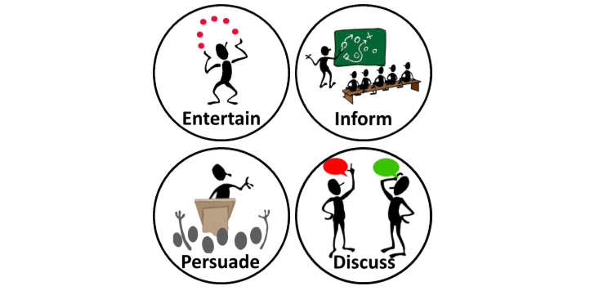
Classes 1 and 2 | 3 half terms | 3 half terms
Classes 3 and 4 | 3 half terms | 2 half terms | 1 half term
Class 5 | 2 half terms | 2 half terms | 1 half term | 1 half term

Examples of text types include:
Examples of texts.
There will be more!
Classes 1 and 2 | Story  Poem  Character  Setting  Role play  Sequencing | Instructions  Report  Recount  Factfile  News report
Classes 3 and 4 | Narrative  Description  Writing in role – letter, diary  poetry | Instructions  Non-chron report  Recount  News report  Biography  Explanation | Advert  Letter  Poster  Leaflet
Class 5 | Narrative  Description  Writing in role – letter, diary  poetry | Reports  Biography / autobiography  Newspaper article  Explanation | Radio / TV advert  Speech  Leaflet  Blog | Argument  Newspaper  Review

Key points for teaching and learning are:

- The balance must be adhered to as above.
- Class teachers can choose which half term to focus on which purpose depending on the theme.
- Within that half term there must be at least 2 full written outcomes. There will also be smaller sections of writing as elements are taught towards the main piece.
- The 2 full outcomes (3 over a short term) will be assessed against the writing targets – and new key targets for pupils will be set using these.
- All pieces of writing within that half term will be for that purpose to consolidate grammar, language and structure features which have similarities.
- Medium term planning will be completed outlining the objectives taught and outcomes intended.
- Where possible writing in other subjects may follow this too – but this is not always possible (e.g. science in ‘entertaining’ half terms).
- The teaching sequence remains the same:
- using good reading models
- drama and speaking and listening
- explicitly taught elements of grammar, language and text structure
- planning models
- writing broken into sections
- proof reading
- editing
- final draft
Teachers promote writing and look for ways to inspire and motivate pupils so that they see themselves as ‘writers’. Teachers establish the purpose and audience for writing and make teaching objectives explicit to pupils so they know why they are studying a particular text type, the kind of writing activities they need to undertake and what the expected outcome will be. The following teaching sequence for reading and writing is used as a framework, though it is not an expectation for all units of work:
The writing process breaks down into a number of steps that will need to be taught and practised regularly:
- Planning
- Drafting and Writing
- Evaluating and Editing
- Proof-Reading
- Reading Aloud and Sharing

Subject-specific texts that link to work being undertaken in other areas should also be used in literacy lessons to support the wider curriculum. Teachers use shared writing to model the writing process. Shared reading and writing provide a context for discussion and demonstration of grammatical features at word level, sentence level and text level. Activities are differentiated through the use of writing frames, spelling banks, collaborative work and peer or adult support. Teachers encourage ‘talk for writing’ as an integral part of the process.

Handwriting
It is paramount that children are rigorously taught correct letter formation from the very beginning of their time in school. As soon as the children are ready, they should be taught to sit properly in order to have the correct posture for writing, hold a pencil in the correct tripod grip and develop a legible and handwriting style. The school teaches a cursive handwriting style from Year 1 through to Year 6. The children in Reception are taught correct letter formation when they are ready to access this part of the Early Years framework. A mixture of whole class, small group and individual teaching is planned for and delivered.
It is expected that all members of staff, class teachers and teaching assistants, model a clear, legible handwriting style, which shows appropriate joins and letter formation i.e. when writing on the board or in children’s books.
By the end of key stage 2, all children should be displaying an efficient, quick, neat and legible handwriting style that is effective in recording their ideas.

Teaching Spelling and Phonics
Aims
Children should:
- Build their knowledge of phonemes progressively over the early years and KS1 years.
- Blend and segment sounds easily
- Learn that segmenting words into their constituent phonemes for spelling is the reverse of blending phonemes into words for reading
- Read and spell common exception words fluently and with automaticity
- Spell words accurately by combining the use of grapheme-phoneme correspondence knowledge as the prime approach, and also morphological knowledge and etymological information
- Use a range of approaches to learn and spell irregular words.

Pupils have access to a range of phonics opportunities that include at EYFS and KS1:
- Daily discrete phonics teaching
- Using phonics knowledge in real life contexts
- Whole class teaching of specific spelling patterns within guided writing as relevant
- Applying skills in cross curricular contexts, including outside and as ongoing provision in EYFS
Pupils have access to a range of phonics opportunities that include at KS2:
- Whole class teaching of specific spelling conventions and rules
- Discrete phonics teaching as part of an intervention group where gaps in phonological knowledge have been identified
- Using phonological knowledge in real life contexts
- Applying skills in cross curricular contexts

Teaching and Learning
Teachers provide a wide range of contexts for teaching and reinforcing knowledge of phonics, spelling patterns and tricky words throughout the school day. All teachers use multi-sensory phonics materials using Phonics Bug and the expectations of the Curriculum 2014 for spelling, as a basis for their planning for the teaching of phonics and spelling. Further details about the teaching of phonics, please see the reading section.
Learning takes place in a variety of situations and group settings. For example, these could include working independently to practise tricky words, possibly using ICT; working collaboratively on an investigation and participating in short, focused whole class activities.
Children are expected to spell high frequency words correctly and the word lists for their particular year group.
Spelling Homework
Edshed is used as a resource to teach and practise specific spelling patterns and reinforce taught phonemic knowledge.
Spellings may be taken from the National Curriculum, differentiated lists from Weekly Spelling Lists or based on spelling patterns and graphemes being learnt in class. It must be stressed that spellings should be based on prior attainment and phonological need and children’s learning should be tested regularly to ensure that spellings are fit for purpose. Dictated sentences are also used to test some spellings each week.

TEACHING resources
Reading
All classrooms have a well-stocked book area with a range of fiction and non-fiction. This is reviewed regularly so that the teacher has a good knowledge of the books available. Pupils also have opportunities to read magazines, listen to story CDs. The school library is an important resource and pupils are taught how to use it appropriately. There are class sets of books in KS2 and these are available for the children to re-read and revisit independently.

Writing
Each class has a range of materials to support the writing process. Writing materials are kept accessible and organised and pupils are encouraged to take care of the equipment and return it to where it belongs. Each class also has a set of age appropriate dictionaries, thesaurus and word banks.

Handwriting, Phonics and Spellings
On line cursive font
Phonics Bug
Support for Spelling
Edshed

contribution to other areas of the curriculum
It is important that all children have the opportunity to apply their reading and writing knowledge across the curriculum, in both science and the foundation subjects. On occasions, content from another subject will be used within the English lesson as the context for writing. Within theme work and science, children will also apply their literacy skills through written response, explanation and writing in any genre pertinent to the context.

equal opportunities and inclusion
All children receive quality first literacy teaching on a daily basis and activities are differentiated accordingly. In addition, where identified pupils are considered to require targeted support to enable them to work towards age appropriate objectives, intervention programmes will be implemented. Teachers and teaching assistants plan programmes together and monitor progress of these pupils.
There will be a third wave of support for pupils who may have specific learning needs, that will be additional and different. This is planned through Individual Provision Maps, and will include advice from other agencies including SALT and LSAT.
Pupils that are more able are planned for through our first quality teaching.
The needs of children with English as an additional language will be met through planning and support from the Multicultural Support Agency, where appropriate. This is supported by our equal opportunities policy.

community links (include link to wiDer community and british values)
Whenever appropriate, links within the local community will be made to ensure a relevant and exciting context for learning within English. This might include using the school grounds, or further afield within the local community.
As opportunities arise, the children will take part in literacy related activities with other schools. This will enable our children to work with others from different schools and other backgrounds and will develop their social and cultural awareness as well as furthering their literacy abilities.
Our curriculum encourages the use of imagination and creativity through literacy. Staff are encouraged to use a wide variety of contexts for writing, including using the outdoor environment, and local opportunities as a stimulus to write. This can be through visits or visitors coming into school. Visits may be theme related or related to a specific subject such as RE. These can then be used as a context for writing and reading.

assessment, recording and reporting
Assessments are made in line with the school assessment policy.

Teachers use effective assessment for learning to ensure planning is based on prior attainment and that pupils know what they need to do to achieve the next steps. The best assessment and feedback is undertaken in the lesson, in the moment of learning, with the children either as a whole class, group or individual. Teaching staff will also use our school target sheets to track progress and to support the children to know their next steps in learning. Distance marking after lessons is kept to a minimum to ensure it supports pupil progress and reduces teacher workload. Staff will use whole class feedback sheets to keep an overview of targets and next steps for the class. This is shared with both the children and other adults in the class.

Analysis of assessment data is used to set individual, group and cohort targets. Where applicable, school issues are addressed through targets linked to the Termly Development Planning and Performance Management.

Through their target sheets, children are informed of their own targets for learning and supported to make progress towards them. Children are also involved in setting their own steps to success and encouraged to review their progress towards these through self, peer and teacher assessment.

review and monitoring
The headteacher is currently the English Coordinator. All monitoring is set out in the School Development Plan and Termly Development Plan. Each term literacy work is monitored through data evaluation, book scrutiny, lesson observation and talking to pupils.

professional development
Teachers are expected to keep up to date with subject knowledge and use current materials that are available in school or online.
Training needs are identified as a result of whole school monitoring and evaluation, performance management and through induction programmes. These will be reflected in the School Development Plan and Termly Development Plan. The English co-ordinator will arrange for relevant advice and information, such as feedback from courses or newsletters, to be disseminated. Where necessary, the English SL leads or organises school based training. This will include regular phonics and reading training.

Additional adults who are involved with intervention programmes will receive appropriate training that may be school based or part of central training.

policy review
This policy will be reviewed fully according to the policy review cycle in January 2024, or as deemed necessary through the School Development Plan.
The coordinator will review the accuracy of the policy on a bi-annual basis or sooner if changes are made across school.

