High Ercall Primary School

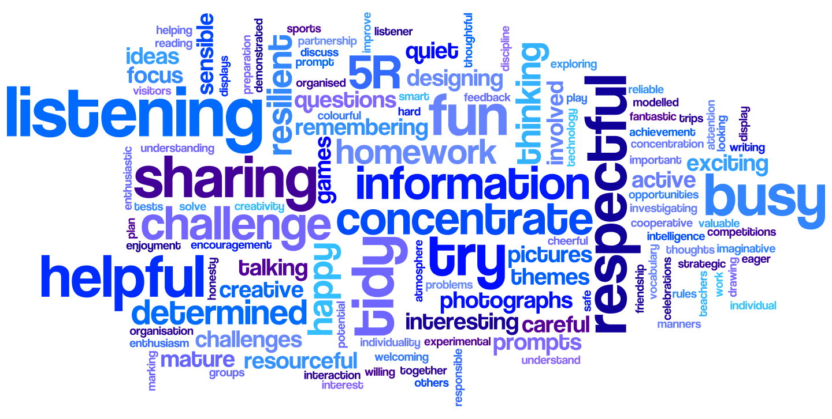

Art Policy

Date of Policy Creation | Spring 2016 | Named Responsibility | Marta Workman
Date of review completion | Spring 2021 | Named  Responsibility
Inception of new Policy | Summer 2021 | Named  Responsibility
Date of Policy Adoption by Governing Body

HIGH ERCALL Primary School Curriculum Policy Guidance for art
INTRODUCTION AND SUBJECT DEFINITION

Art, craft and design represents the variety of approaches of human creativity. A high-quality art and design education should engage, inspire and challenge pupils, equipping them with the knowledge and skills to experiment, invent and create their own works of art, craft and design. As pupils progress, they should be able to think critically and develop a more rigorous understanding of art and design. They should also know how art and design both reflect and shape our history and contribute to the culture and creativity. Art offers children a unique way of communicating that can inspire and motivate them. It is a vehicle for personal expression and can play an important part in their personal development as people. We provide opportunities for all children to create and investigate drawing, painting and 3D work, to develop their knowledge and skills to appreciate a wide variety of art forms and to begin to make judgments about the quality of their own work.
Purpose of study
At High Ercall, we ensure that art is an enjoyable and fun learning experience. We encourage children to build up their substantive knowledge by participating in a variety of activities involving different media, introducing them to different art movements through history. They are also encouraged to consider how quality and value have been expressed by experts. We endeavour to make art relevant, linking it where possible to cultural themes, interests, artistic movements and personal experiences.

Aims

At High Ercall Primary, we value art in our teaching programme.
We…
• Develop the capacity to express ideas and feelings symbolically through various media
• Develop skills and concepts whilst engaged in art activity
• Develop social skills and awareness through sharing responses
• Offer pupils opportunities to experience personal satisfaction and self-confidence when involved in art and craft activities
• Offer opportunities of self-expression which give an insight into areas of experience that cannot easily be verbalised
- Develop an awareness and appreciation of a variety of cultures and societies
• Develop an awareness and appreciation of the style of artists through history
- encourage pupils to develop an evaluative response to their work and that of their peers

Curriculum organisation
Although art is taught as a separate subject, we endeavour to make cross-curricular links, where possible, in our medium term planning.

- Lessons make effective links with other curriculum areas and subjects, where possible.
- Activities are planned to be challenging, motivating and aim to extend pupils’ learning.
- As they move through school, pupils experience frequent opportunities to develop their skills and select and use appropriate tools and mediums, and combine these for a given purpose with confidence and increasing independence.
- Each year has a main focus which is divided into three main approaches: drawing, Painting and 3D work. Opportunities to include pattern and textiles can be included, where appropriate. A study about a famous artist is introduced linked to this. This becomes the starting point of the medium term’s work.
- The pupils work individually, in pairs, as part of a small group and as a whole class within the unit. They use a variety of means for communicating and recording their work.
- Pupils use sketchbooks to record their work, ideas and opinions about their own work, as well as the work of their peers and famous artists.
- All pupils, including those with special educational needs, undertake the full range of activities. Teacher assessment determines the depth to which individuals and groups go during each unit of work.
Expectations
The school ensures curriculum continuity by close liaison between staff and the planning stages.
In Key stage 1, pupils are taught to:
- to use a range of materials creatively to design and make products
- to use drawing, painting and sculpture to develop and share their ideas, experiences and imagination
- to develop a wide range of art and design techniques in using colour, pattern, texture, line, shape, form and space
- to consider the work of a range of artists, craft makers and designers, describing the differences and similarities between different practices and disciplines, and making links to their own work.

Key stage 2 pupils are taught:
- to develop their techniques, including their control and their use of materials, with creativity, experimentation and an increasing awareness of different kinds of art, craft and design.
- to create sketch books to record their observations and use them to review and revisit ideas
- to improve their mastery of art and design techniques, including drawing, painting and sculpture with a range of materials [for example, pencil, charcoal, paint, clay]
- to compare the work of great artists, architects and designers in history.

resources
Specific year group resources are kept in teachers’ classes. All other general resources are kept in the school stock cupboard. Books can be found in the library. The School Library Service can be accessed for artifacts, books and posters. The local authority support and offer CPD. Take One Picture resources online also offer resources that staff can use.

health and safety
When planning particular activities, where safety procedures need to be put in place, such as batik, all teachers must complete a risk assessment. Teachers should refer to the school’s Health and Safety Policy and the safety procedures set out in previous risk assessments.

equal opportunities and inclusion
It is the aim of the school to ensure that opportunities and facilities are available to everyone who studies music

- We will ensure that the educational needs of all pupils are properly assessed.
- We will identify those barriers (physical, environmental and curricular) which could prevent individuals from accessing the learning opportunities the school provides, and seek to remove them, making reasonable adjustment though our best endeavours to promote inclusion.
- We will seek to provide a supportive and welcoming atmosphere.
- We will employ a range of teaching styles to ensure no pupil is excluded from learning and to enable pupils to achieve success.
- We will challenge inappropriate attitudes and practices directly. This might involve quiet conversations with individuals, speaking with groups of children, broader messages through Meeting for Worship
- We will model positive behaviours to demonstrate our commitment to equality of opportunity.

GIFTED AND TALENTED PUPILS
Those children that show a particular ability for art are directed towards any external classes, exhibitions and group opportunities in the local area.

community links
Working with other schools, in the ‘Rural Arts’ projects, gave us the chance to join together, visit galleries, work with artists and display work for a wider audience. We continually look for opportunities to be involved with the wider community and give the work purpose and real context eg. Planning and making the school wall plaque, tree dressing of the Gospel Oak, Grayson Perry styled Comfort Blanket and Big Art projects

assessment, recording and reporting
We ensure that all lessons have clear learning objectives, which are shared and reviewed with the pupils effectively. Varieties of strategies are used to assess progress: self-assessment, peer-assessment and a final piece. An assessment is recorded in the pupils’ end of year report.

review and monitoring
The Art subject leader will undertake monitoring, feedback and review.

professional development
The subject leader, if appropriate will disseminate any courses or CPD, which the subject leader attends, to staff. Where appropriate, courses are referred to relevant members of staff.

policy review
The subject leader will review the policy in the summer term 2022.

