Hi,
Thank you for taking the time to stay and listen to the Online Safety session for parents and carers. Whether you were able to attend or not I wanted to share the main points from the session and links to some of resources that you will find useful when looking to discuss online safety with your children or reviewing the online environment that is being accessed at home.
Focus for the session: In real life you would protect your children….so why not protect them on the internet
Link to Where’s Klaus video https://www.youtube.com/watch?v=i4GKXsAOYZE

Online safety is classified into three areas of risk:
- Content: Being exposed to illegal, inappropriate or harmful material
- Contact: Being subjected to harmful online interactions with other users
- Conduct: Personal online behaviour that increases the likelihood of, or causes harm

What do we (teachers, parents and carers) need to do?
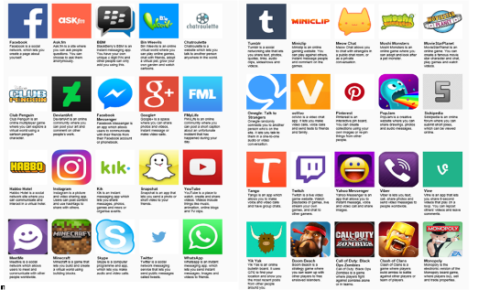
- Build capacity for smart decision making…so children will make the right decisions when they are on their own and with their siblings and peers
- Create a culture for sharing and discussing in a safe environment
  - Discuss what’s new
  - On line behaviour
- Keep up to date with ever changing technology (how many social networking sites have you heard of or do you use? Do you know where there are child friendly alternatives)? Example KidsTube, SnapKidz)
Much of what our children learn about being online will come from their peers and other online users (examples including tutorials on youtube). As soon as children begin to explore the online world; whether it be watching content online, using websites or having a social media presence it is important to take an interest in what they are doing.

Resources available to you online
NSPCC – online safety what parents need to know. Excellent starting point
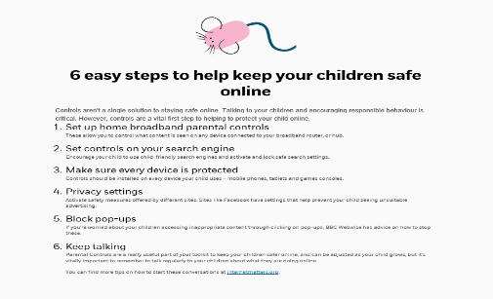
https://www.nspcc.org.uk/search/?query=online%20safety%3A%20what%20parents%20need%20to%20know%20
NSPCC – Online Safety
- What children do online
- The risks and dangers of children being online
- Staying safe on mobiles and tablets
https://www.nspcc.org.uk/search/?query=online%20safety%3A%20what%20parents%20need%20to%20know%20

Ensuring that your home is set up for all online users…no matter their age
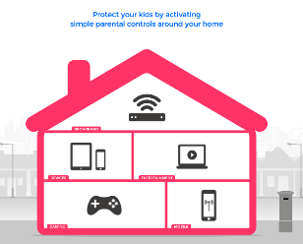
https://www.internetmatters.org/parental-controls/interactive-guide/
- Do you know about parental controls?
- Have you set them?
- Are all users equal in your house?

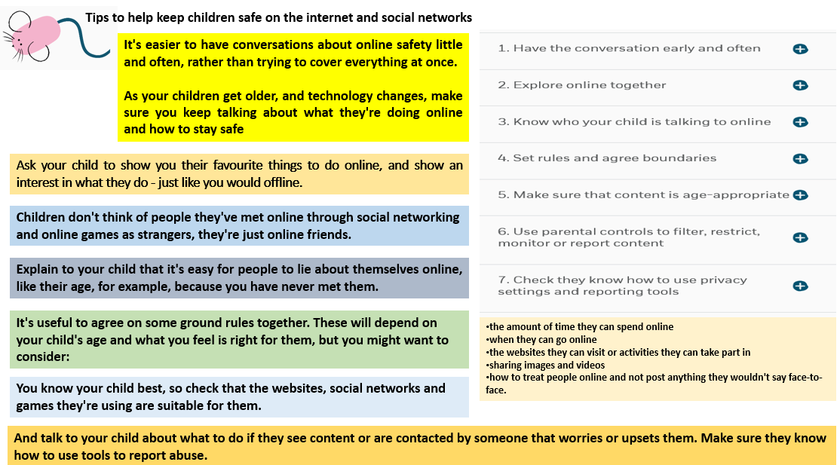
Things to consider - NSPCC

Educational resources – suitable for KS1 and lower KS2 (years 1 – 4) often used in school
ThinkUKnow – Hectors world https://www.thinkuknow.co.uk/5_7/
ThinkUKnow – Parents and Carers https://www.thinkuknow.co.uk/parents/
Childnet – Digiduck http://www.childnet.com/resources/digiducks-big-decision
Childnet – Smart Crew http://www.childnet.com/resources/the-adventures-of-kara-winston-and-the-smart-crew
Video: Jigsaw ‘Becky aged ten’ https://www.youtube.com/watch?v=_o8auwnJtqE

What is Cyber Bullying?
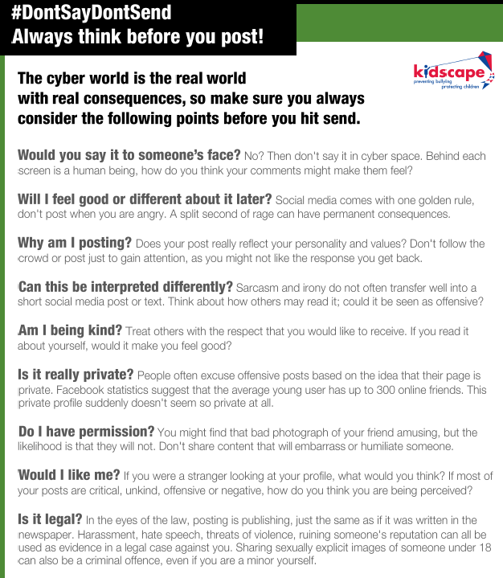
Teaching young people to be kind online and see the internet as an extension of real life

Remember:
Teaching children to use the internet and other online environments (including games and apps) is like teaching road safety. It’s about;
- Modelling safe behaviour
- Ensuring that children understand how to stay safe, are aware of the potential risks and know what to do if an incident occurs
- Increasing independence at an appropriate time for each individual child
Just like roads, the online world will always pose an element of risk (that does not change, even for the most road safety conscious, accidents happen). We as parents, carers and teachers are entrusted with ensuring that children have safe environments to operate in, are well educated about the risks of being online to themselves and others and that THEY ARE SMART DECISION MAKERS when it comes to being part of the online and digital world.
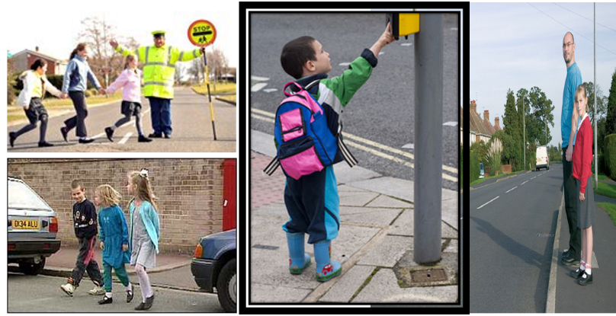
If you require any additional support of information, please do not hesitate to contact me.
Rebecca Carey rebecca.carey@telford.gov.uk

