High Ercall Primary School

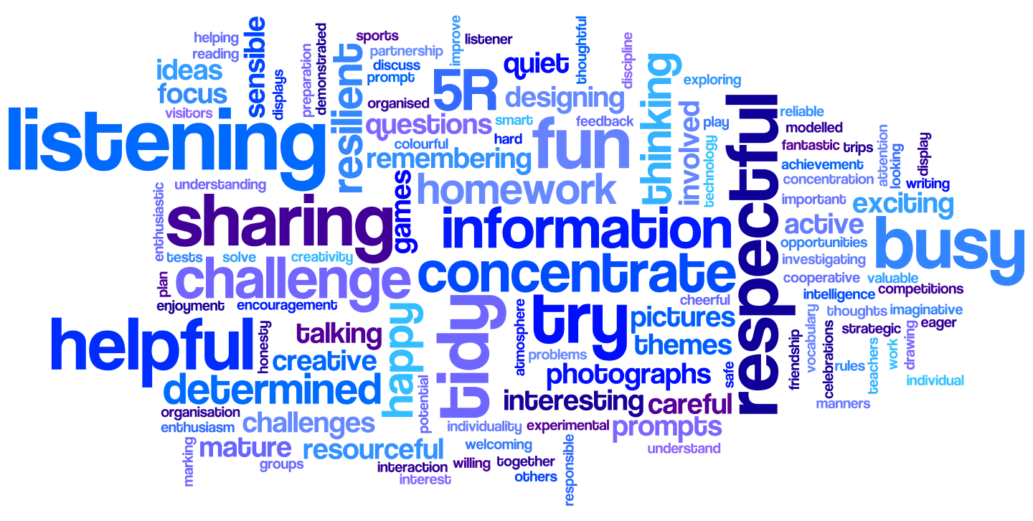

Assessment Policy 2020
(Planning, assessment, record keeping and recording)

Policy- Document Status
Review of Policy | April 2020 | Named  Responsibility | Sarah Roberts
Date of Policy Adoption by Governing Body |  | 2020
Next review date |  | April 2022

High Ercall Primary School - Assessment Policy 2020

Rationale

The purpose of this policy is to support school improvement and the raising of standards of achievement, for all pupils. Assessment is a continuous process, which is integral to teaching and learning, allowing children to reach their true potential.

Aims

All assessment should:

- Enable pupils to make progress in their learning
- Be underpinned with the confidence that every child can improve
- Help all pupils to demonstrate what they know, what they can do and what they understand
- Include reliable judgements about how learners are performing related, where appropriate, to national standards
- Involve both the teacher and pupil reviewing learning and reflecting upon next steps in learning and how they can be achieved
- Enable teachers to plan effectively
- Enable parents to be involved in their child’s progress
- Inform target setting for the whole school, groups, cohorts and individual pupils.
- Enable any learning difficulties to be identified quickly and appropriate help given
- At a strategic level, provide information to inform the school’s development planning
- Provide the school with information to evaluate learning and set suitable targets.

Roles and Responsibilities

Teachers and Teaching Assistants are responsible for carrying out both formative and summative assessments (see later in the policy) with individual pupils, groups and whole classes. Where appropriate, these outcomes will be shared with the pupils as part of an ongoing dialogue about their learning progress. Outcomes are also shared with parents at parent conversation meetings and within Annual Pupil Reports.

The Headteacher is responsible for:
- Monitoring standards
- Analysing pupil progress and attainment, including individual pupils and vulnerable groups
- Identifying vulnerable pupils at risk of under achievement
- Prioritising key actions to address under achievement, including the deployment of staff
- Reporting to Governors on all aspects of pupil progress and attainment, including standards and trends.
- Holding staff to account for pupil progress
- Target setting for the school, cohorts, groups and individual pupils.

Deputy Head and Early Years Manager are responsible for:
- Monitoring standards in their subject according to standards set out in the EYFS framework or National Curriculum
- Ensuring all staff are familiar with the assessment policy, practise and expectations
Subject Leaders are responsible for:
- Monitoring standards in their subject according to standards set out in the EYFS framework or National Curriculum
The teacher is responsible for:
- Planning in the short and medium term to meet the needs of all pupils
- Marking all work in line with the school policy – marking with the children is best.
- Ensuring that marking includes ongoing feedback, distance ‘R’ tasks or verbal feedback, to inform the children of next steps in their learning and addressing gaps in learning
- Enabling the pupils to assess their own learning and that of their peers.
- Undertaking summative testing to inform teacher judgement
- Conducting ongoing assessment using pupil target sheets which will inform staff, children and parents
- Inputting pupil data into Bromcom
- Planning intervention to address learning needs
- Sharing the needs of pupils with TA staff to keep them fully informed
- Ensuring all pupils within vulnerable groups are adequately supported
Key Features of Assessment at High Ercall Primary School

Assessment for Learning (formative assessment)

Assessment for learning is an integral part of teaching and learning. It is based upon how well pupils achieve learning objectives, and providing feedback to involve the pupils in improving their learning. Peer and self-assessment are actively encouraged for children in Year 1 upwards.
Strategies used in school:

- Planning – good planning ensures that there are clear learning objectives, matched to the differing needs of the pupils and pitched used the National Curriculum 2014. Staff may keep their own evaluated plans include notes relating to the ongoing assessment of pupils and the adaptation of planning to suit the needs of all pupils.
- Sharing learning objectives and success criteria with pupils – the children are fully involved in understanding the purpose of their learning and what they need to do to succeed
- Peer and self-assessment – pupils are trained and given time to evaluate their own and their peers’ achievements against the learning objective and success criteria. Sometimes this will be in a written form. At others it will be verbally. Older children will be involved in setting learning targets linked to pupil target sheets which are in the front of the children’s books.
- Marking and feedback – all pupil’s work is marked using starred success criteria and an arrow to indicate next steps. The best feedback is verbal, with the children, during a lesson. Where possible this occurs – given by teachers and teaching assistants. Distance marking has less value and is minimal. R tasks may be set for pupils to address errors where they will add value to their learning.
- Target setting – pupil target sheets are in all maths and English books for teachers and children to use to inform next steps in learning. The children in Key Stage 2 will evaluate their targets using work in their books, thinking about what they know, they can do and they understand. Target sheets are also used half termly in reading in KS2. In KS1 targets are stuck into reading diaries after each reading session.
- Celebrating achievement – all aspects of achievement are celebrated within school in a variety of ways. The children are also involved in nominating themselves and their peers for celebration.
Summative Assessment

Summative testing takes a snapshot of learning which establishes what a child can do at a given time.
These strategies are used in school:

- Statutory Assessments – pupils are assessed at the end of Key Stage 1 and Key Stage 2 through national tests. These provide a summative end of key stage attainment result, and can be compared to national outcomes. Pupils in Reception are assessed on entry using the new statutory baseline assessment – due to be in place in September 2020.
- Non-statutory tests – commercially produced tests (PUMA, PIRA) are administered voluntarily in school twice a year to evaluate attainment against year group expectations in the national curriculum.
- Termly teacher assessments – progress and attainment are measured termly against the year group expectations. Evidence in pupils’ books is used to support judgements.
- End of year teacher assessments – teacher assessment is made in all year groups through to Year 6. Non – statutory tests are used to inform teacher assessments.

Tracking and recording attainment and progress

Foundation Stage - Reception
- Term 1
Information prior to starting school via:
Entry profile information from High Ercall Nursery, information from other private providers, parental consultations in week 1
Baseline completed – in the first 4 weeks – literacy and numeracy only
Foundation stage profile completed by half term
End of Term 1 – use foundation profile to review progress. Data entered onto Bromcom. Early Years leader reviews progress and attainment across the Foundation stage
Progress and attainment data shared with Governing Body
- Term 2 / 3
Maintain Foundation Profile through teacher assessment and evidence in Learning Journey.
End of term – teacher assessment updated on Bromcom
Early Years Manager to review attainment and progress across Foundation Stage
Identify children at risk of under achieving to target for next term
Progress and attainment data shared with Governing Body
At half term, Term 2 - Parent conversation meeting to share progress, attainment and targets
- End of Term 3
Annual Report to parents
Parent open evening
Early Years Manager to review attainment and progress across Foundation Stage for the year

Years 1,2,3,4,5,6
- Terms 1,2,3
Pupils assessed against year group expectations in National Curriculum 2014.
Pupil target sheets completed for writing and maths within units of work.
Half termly reading targets in Guided reading books (new for September 2020)
End of each term – pupil targets sheets used to inform teacher assessments
PUMA / PIRA summative tests completed
Teacher assessment, using summative tests, entered into Bromcom
Subject coordinator to review attainment and progress of cohort, vulnerable groups, and individual pupils
Identify children at risk of under achieving to target for next term
Pupil Progress meetings held at the end of each half term – intervention reviewed and adapted to needs of pupils
Progress and attainment data shared with Governing Body
At half term in Terms 1 and 2: Parent conversation meeting to share progress, attainment and targets
- End of Term 3
Annual report to parents
Parent Open Evening

Year 1 (in addition to above)
- Term 1 – some pupils may continue with FSP, others will be assessed against the year group expectations.
- Term 3 – Phonics check carried out. Results shared with parents as part of Annual Report.
Years 2 and 6 (in addition to above)
- Term 3 – SAT tests and tasks administered as per statutory administration
SAT results shared with parents as part of Annual Report

Pupil Progress Meetings
Pupil progress meetings are designed so that the progress of individuals and groups can be discussed with the SLT and teachers. This enables staff to share approaches to supporting pupils learning, but also ensures accountability for attainment and progress. Following the meeting, staff adapt and amend intervention sheets to show changes to intervention and address concerns about individual pupils or pupils within vulnerable groups. This will include all children in receipt of Pupil Premium, including service children.

Tracking
All staff enter data into Bromcom before the end of the term.
SLT use data entered to run reports to show attainment and progress of each cohort. This is analysed for trends and concerns across school and used to plan the subsequent Termly Development Plan. Within the data analysis there is a focus upon:
- Gender variation in attainment or progress
- Children in receipt of PPG funding
- Children in Care
- Service children
- Children with SEN
- Higher attaining pupils
- Pupils with different Ethnic backgrounds
Due to the small size of some vulnerable groups, it is important to evaluate individual progress, rather than relying on statistical evidence which can be distorted with such small groups.

Transition
On transfer to another school, or at the end of Year 6, records of attainment are shared with the receiving school, as well as further information with regards to interventions and additional provision.

Monitoring, Moderation and Evaluation
Senior managers (Head, Deputy and Early Years Manager) take responsibility to ensure that agreed procedures are put into place across school. Policy and practice will be reviewed with all staff to evaluate the effectiveness and efficiency of assessment arrangements.

Monitoring
Book scrutiny and lesson observations will monitor whether agreed assessment procedures are being consistently applied. At the start of each staff PDM, staff share 2 books which evidence formative assessment procedures in place. This enables good practice to be shared.

Moderation
Moderation takes place in a variety of ways, and ensures that teachers’ judgements against the age related objectives in Curriculum 2014 are sound, and agreed.
- In school moderation is part of the Termly Development Plan each term. Staff bring along a sample of work for an agreed subject and judgements are discussed. This can include creating a portfolio of samples of agreed expected standards.
- SDG moderation. Each term there is a subject focus for our group of schools to moderate – Science, Maths, Writing, EYFS. Subject coordinators take a sample of work which is moderated and agreed across the schools. This is led by a Head from the group and an advisor. Secondary and Primary schools are involved.
- LA moderation. Termly meetings are attended by subject leaders. The school Early Years Manager attends EYFS moderation meetings within the LA. Staff in Year 2 and Year 6 attend moderation meetings for writing. On a cycle within the LA, the school will be selected for moderation of SATs or EYFS.

Evaluation of data
End of term data is scrutinised by SLT. Trends and concerns are evaluated and feed into the Termly Development Plan. This information is shared with Governors through the Head’s Report each term. At the end of the year, the data from SATs, along with Phonics data, EYFS GLD results and internal tracking data across school is used by the SLT and Strategic Committee of the Governing Body to evaluate school strengths and areas for development. These will feed into the School Development Plan for the subsequent year.

Parental Consultation
Parent Conversation Meetings take place in Term 1 and Term 2, by half term. They are used to share information about attainment in relation to age related objectives, and compared to national, progress a pupil has made, and their effort in learning. Parents are able to view pupils work and classroom, look at pupil target sheets within books and share test results as applicable. In Term 3, following the Annual Report to Parents, there is a less formal open evening to view work from the year and talk to staff. If a more specific meeting is required, this can be booked with staff.
Through the term, all staff are available for more informal meetings to discuss progress concerns or any other aspect of learning. These may be called by staff or parents.
There are informal opportunities to share in learning during each term, through open afternoon sessions, or opportunities to share in lessons.
The Annual Report to Parents is written and shared with parents at the end of Term 3, and contains detail about progress and attainment in all subject areas. In the core areas of English, Maths and Science, detailed comments are given and evaluations of attitude to learning are included. The report details attainment in all aspects of these subjects, achievements in relation to national expectations, and effort in all areas of learning. End of Key Stage SAT results, Phonics tests in Year 1 or retakes in Year 2, EYFS attainment and attendance records are also included. Pupils are set next steps in learning for English, Maths and Science.

