High Ercall Primary School

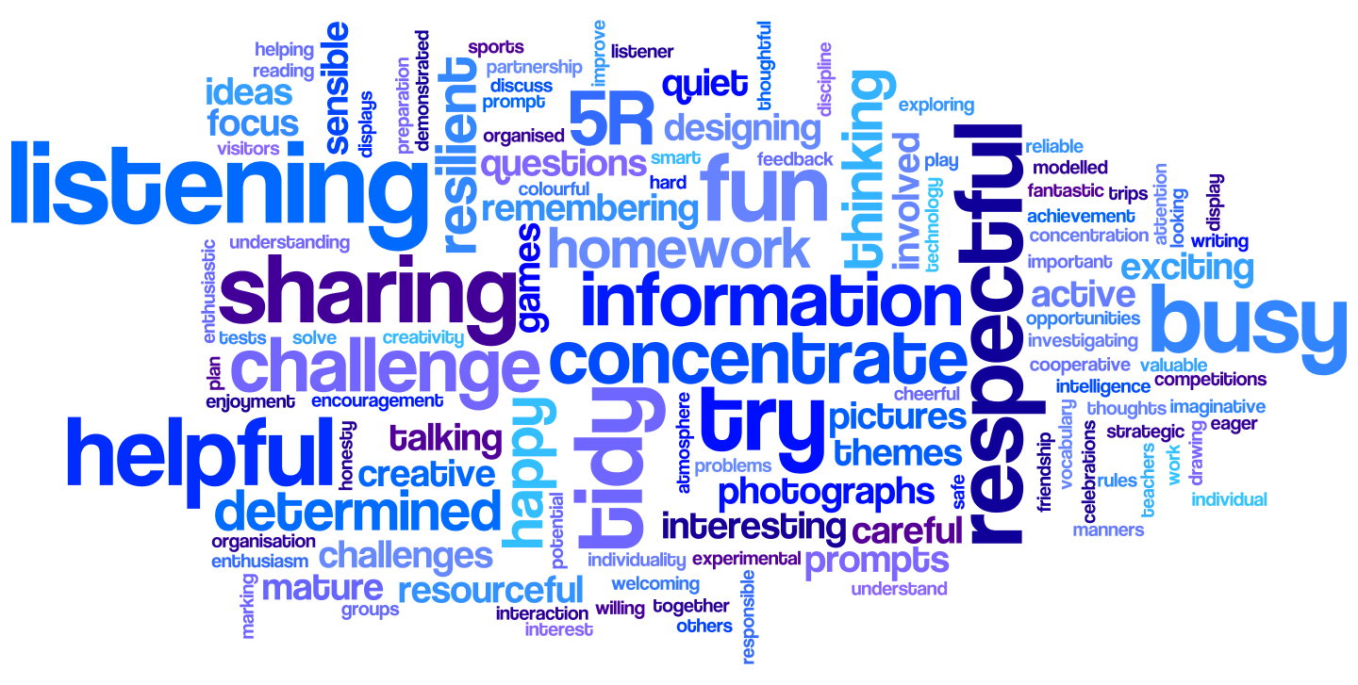

Science Policy

Date of Policy Creation | November 2023 | Named Responsibility | Jemma Wallace
Date of review completion |  | Named  Responsibility | Jemma Wallace
Inception of new Policy |  | Named  Responsibility | Sarah Roberts
Date of Policy Adoption by Governing Body

HIGH ERCALL Primary School Curriculum Policy Guidance for SCIENCE

Introduction and Aims
The intent of our Science curriculum is to deliver a curriculum which is accessible to all and that will maximise the outcomes for every child so that they know more, remember more and understand more. At High Ercall Primary School we recognise the importance of Science in every aspect of daily life and encourage children to be inquisitive throughout their time at school and beyond. We want children to develop an enthusiasm and enjoyment of scientific learning, and discovery, and to build upon their resilience and problem solving skills. We aim to ensure that children know and remember more through their development of substantive knowledge (facts, concepts and laws) and disciplinary knowledge (working scientifically). Substantive knowledge is revisited regularly through recaps during lesson starters, quizzes and the use of mind maps.
We ensure that children access the National Curriculum through carefully planned topics for each year group.

The 2014 National Curriculum for Science aims to ensure that all children:
- develop scientific knowledge and conceptual understanding through the specific disciplines of biology, chemistry and physics
- develop understanding of the nature, processes and methods of science through different types of science enquiries that help them to answer scientific questions about the world around them
- are equipped with the scientific skills required to understand the uses and implications of science, today and for the future.

At High Ercall we believe that the transfer of skills from the other core subjects is important and necessary to the teaching of Science. The quality and variety of language that pupils hear and speak are key factors in developing their scientific vocabulary and articulating scientific concepts clearly and precisely. We ensure that pupils are assisted in making their thinking clear, both to themselves and others, and we build secure foundations by using discussion to probe and remedy their misconceptions. We feel that pupils should be able to describe processes and key characteristics in their own words, but they should also be familiar with, and use, technical terminology accurately. We enable them to build up an extended specialist vocabulary, which is supported through our use of ‘vocabulary walls or mats’ for each topic area. Pupils are also taught, and are expected, to apply their mathematical knowledge to their understanding of science, including collecting, presenting and analysing data as part of working scientifically. These links with maths ensure that disciplinary knowledge is gained and maintained through regular rehearsal.
We ensure that the Working Scientifically skills are built-on and developed throughout children’s time at the school so that they can apply their knowledge of science when using equipment, conducting investigations, building arguments and explaining concepts confidently. This enables them to continue to ask questions and be curious about their surroundings.

Curriculum organisation and time allocation
Science is taught for one afternoon per week and there is a clear and progressive long-term plan detailing topic areas and when to teach them. We use HLTA support for some Science teaching to ensure that all year groups can be taught individually, rather than in their usual mixed age classes, to ensure that the content and coverage is age appropriate and not repeated throughout their time at High Ercall. The ‘White Rose Science’ scheme of work is used across school, ensuring a challenging curriculum offer with a clear development of skills and knowledge. ‘White Rose’ have carefully organised and planned the learning to ensure that the scheme has suitable links to age-appropriate maths skills throughout. There is also a clear expectation for progression of the ‘working scientifically’ elements for all year groups.

Expectations
The principal focus of science teaching in key stage 1 is to enable pupils to experience and observe phenomena, looking more closely at the natural and humanly-constructed world around them. They should be encouraged to be curious and ask questions about what they notice. They should be helped to develop their understanding of scientific ideas by using different types of scientific enquiry to answer their own questions, including observing changes over a period of time, noticing patterns, grouping and classifying things, carrying out simple comparative tests, and finding things out using secondary sources of information. They should begin to use simple scientific language to talk about what they have found out and communicate their ideas in a variety of ways. Most of the learning about science should be done through the use of first-hand practical experiences, but there should also be some use of appropriate secondary sources, such as books, photographs and videos. ‘Working scientifically’ is described separately in the programme of study, but must always be taught through and clearly related to the teaching of substantive science content in the programme of study.

Pupils should be taught about:
- Plants
- Animals including humans
- Everyday materials
- Seasonal changes
- Living things and their habitats
Source (National Curriculum 2014)

The principal focus of science teaching in lower key stage 2 is to enable pupils to broaden their scientific view of the world around them. They should do this through exploring, talking about, testing and developing ideas about everyday phenomena and the relationships between living things and familiar environments, and by beginning to develop their ideas about functions, relationships and interactions. They should ask their own questions about what they observe and make some decisions about which types of scientific enquiry are likely to be the best ways of answering them, including observing changes over time, noticing patterns, grouping and classifying things, carrying out simple comparative and fair tests and finding things out using secondary sources of information. They should draw simple conclusions and use some scientific language, first, to talk about and, later, to write about what they have found out.
Pupils should be taught about:
- Plants
- Animals including humans
- Rocks
- Light
- Forces and magnets
- Living things and their habitats
- States of matter
- Sound
- Electricity
Source (National Curriculum 2014)

The principal focus of science teaching in upper key stage 2 is to enable pupils to develop a deeper understanding of a wide range of scientific ideas. They should do this through exploring and talking about their ideas; asking their own questions about scientific phenomena; and analysing functions, relationships and interactions more systematically. At upper key stage 2, they should encounter more abstract ideas and begin to recognise how these ideas help them to understand and predict how the world operates. They should also begin to recognise that scientific ideas change and develop over time. They should select the most appropriate ways to answer science questions using different types of scientific enquiry, including observing changes over different periods of time, noticing patterns, grouping and classifying things, carrying out comparative and fair tests and finding things out using a wide range of secondary sources of information. Pupils should draw conclusions based on their data and observations, use evidence to justify their ideas, and use their scientific knowledge and understanding to explain their findings.
Pupils should be taught about:
- Living things and their habitats
- Properties and changes of materials
- Earth and space
- Forces
- Evolution and inheritance
- Light
- Electricity
Source (National Curriculum 2014)

Teaching and learning

Our whole school approach to the teaching and learning of Science involves the following;

- Problem solving opportunities that allow children to find out for themselves. Children are encouraged to ask their own questions and be given opportunities to use their scientific skills and research to discover the answers. This curiosity is celebrated within the classroom. Teachers use precise questioning in class to test conceptual knowledge and skills, and assess children regularly to identify those with gaps in learning.
- We build upon the learning and skill development of the previous years. As the children’s knowledge and understanding increases, and they become more proficient in selecting, using scientific equipment, collating and interpreting results, they become increasingly confident in their growing ability to come to conclusions based on real evidence.
- Working Scientifically skills are embedded into lessons to ensure that they are developed throughout the children’s school career and new vocabulary and challenging concepts are introduced through direct teaching. This disciplinary knowledge is developed through the years, in-keeping with the topics that build upon previous learning. .
- Teachers demonstrate how to use scientific equipment, and the various Working Scientifically skills, in order to embed scientific understanding. Teachers find opportunities to develop children’s understanding of their surroundings by accessing outdoor learning and workshops with experts where possible.
- Children are offered visits, trips and visitors to complement and broaden the curriculum. These are purposeful and link with the knowledge being taught in class. There is also an extra-curricular ‘Science Club’ once a week after school open to all pupils in Key Stage 2 which focusses on broadening knowledge and carrying out a range of fun investigations.
- Mind maps are used in all classes to determine prior knowledge at the start of a topic. A new map is then created and added to each week as the learning evolves. Children use this to recap what they have learnt so far and may take part in short quizzes at the start of a lesson to determine progress, understanding and raise any possible misconceptions.
- Subject specific vocabulary is displayed in classes and identified through medium-term plans then highlighted to the children at the beginning of lessons through mind maps or vocabulary walls in classrooms. New vocabulary is revisited regularly and, in Key Stage 1, children use actions to help them to remember the meanings of new words.
- Scientific enquiry posters are displayed in class and used to develop the pupils’ understanding, together with miniature versions that are glued in books alongside any investigations that take place.

resources
Specific year group resources may be kept in teachers’ classes. All other general resources are kept in a Science cupboard in the Victorian building. Books can be found in the library and the School Library Service can be accessed for additional books and resources.

health and safety
There is a Science risk assessment in the school ‘Risk assessments’ folder and more detailed, or topic specific, risk assessments can be found at www.cleapss.org.uk. The ‘White Rose’ scheme also details any areas linked to safety, where they may be risks, in the individual lesson plans.
When planning trips, or inviting visitors into school, all teachers are required to gain permission from the head teacher before confirming a booking. The teachers must also complete a risk assessment, even if it is a site they have visited previously. Teachers should refer to the school’s Health and Safety Policy and the safety procedures recommended in the DfES ‘Health & Safety of Pupils on Education Visits’ guidelines.

equal opportunities and inclusion
It is the aim of the school to ensure that opportunities and facilities are available to everyone who studies Science.

- We will ensure that the educational needs of all pupils are properly assessed.
- We will identify those barriers (physical, environmental and curricular) which could prevent individuals from accessing the learning opportunities the school provides, and seek to remove them, making reasonable adjustment though our best endeavours to promote inclusion.
- We will seek to provide a supportive and welcoming atmosphere.
- We will employ a range of teaching styles to ensure no pupil is excluded from learning and to enable pupils to achieve success.
- We will challenge inappropriate attitudes and practices directly. This might involve quiet conversations with individuals, speaking with groups of children or broader messages through assemblies.
- We will model positive behaviours to demonstrate our commitment to equality of opportunity.

community links
Science at High Ercall contributes to the local community by promoting the understanding and preservation of the local area (through units about sustainability, animals and habitats) and using the community to further enrich the Science curriculum (E.g. inviting in parents and local businesses). The school also plans a yearly event exploring different jobs in our community, which often links to the scientific skills needed within those jobs.
There are also links to the wider community through learning about famous scientists.

assessment, recording and reporting
We assess children’s work in Science by making informal judgements as we observe them during lessons, by the use of a mind map at the beginning of a lesson to recap prior learning and with the use of ‘quick quizzes’ for assessment of fact retrieval. We mark a piece of work once it has been completed and we comment as necessary. An assessment is recorded in the pupils’ end of year report. Formative assessments are made against statutory end of key stage objectives.
All of our staff, senior leaders and Governors are involved in measuring the impact of our Science curriculum in differing ways.

review and monitoring
The Science subject leader will undertake monitoring, feedback and review. There will also be moderation of learning across the staff team as part of a CPD session.

professional development
Any courses or CPD, which the subject leader attends, will be disseminated to staff by the subject leader, if appropriate. There will also be dedicated CPD sessions each year, led by the subject leader, which will link to the school development plan and any evolving changes/ updates.

policy review
The policy will be reviewed by the subject leader in 3 years or earlier if appropriate.
Policy Review: New policy created November 2023 (updated April 2024 for use from September 2024)
To be reviewed in 2026, or before if the curriculum requires change.

