**High Ercall Primary School**

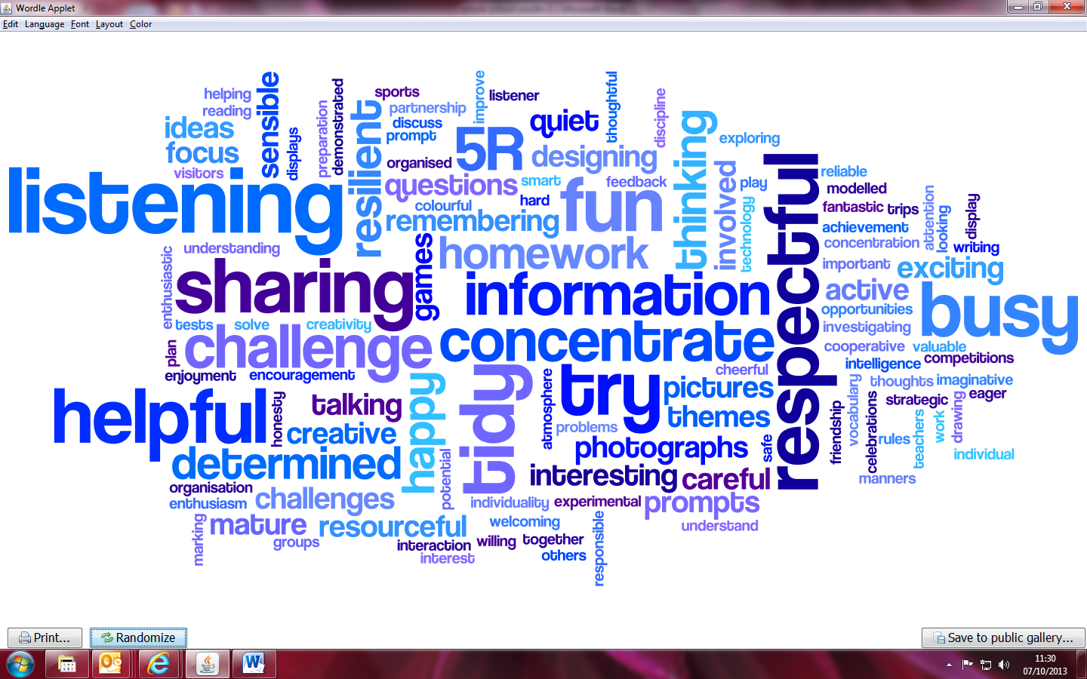

**Feedback and Marking Policy 2022**

|  |  |  |  |
| --- | --- | --- | --- |
| **Policy- Document Status** | | | |
| **Review of Policy** | **December 2022** | **Named**  **Responsibility** | **Sarah Roberts** |
| **Date of Policy Adoption by Governing Body** | | **Delegated to HT** | |
| **Next review date** | | **November 2024** | |

**Marking and Feedback Policy**

**RATIONALE**

High Ercall Primary School is committed to providing relevant and timely feedback to pupils, both orally and in writing. All marking and feedback values pupils’ learning, helps to diagnose areas for development or next steps, and evaluates how well the learning task has been understood in order to inform planning.

Research shows that good feedback is the most important factor in pupil learning, so this policy is crucial for our school.

**AIMS**

**We aim to:**

* Assess children’s learning
* Take learning forward
* Provide consistency and continuity in marking throughout the school so that children have a clear understanding of teacher expectations
* Use the marking system as a tool for formative on-going assessment
* Improve standards by encouraging children to give of their best and improve on their last piece of work
* Develop children’s self-esteem through praise and valuing their achievements
* Create a dialogue which will aid progression

**Aims of this document:**

- To understand the purposes of marking and feedback in school.

- To support appropriate approaches and methods of feedback.

**What is feedback?**

Feedback is an important form of communication between the teacher and pupil, through:

* diagnostic comments and / or a code to make improvement;
* verbal discussion between an adult or child, or a discussion between children.

Reasons for feedback:

* to recognise, encourage and reward effort and achievement and celebrate success;
* to provide dialogue between teacher and child and provide appropriate feedback about strengths and areas to improve in their work;
* to improve a child’s confidence in reviewing their own work and setting future targets;
* to indicate how a piece of work could be improved;
* to identify pupils who need additional support / more challenging work;
* to develop quality through systematic feedback which is acted upon by the child;
* to aid curriculum planning, teaching and learning.

**How do we provide feedback?**

To achieve a whole school approach, feedback methods are agreed and should be age appropriate and developmental.

The nature of feedback

* Feedback may be oral or written, formal or informal.
* Feedback may be given on an individual, group or class basis.

Feedback methods / classroom practice:

1. **Pupil review:** closed exercises may be reviewed by going through them together while children indicate success and correct errors, mistakes or incorrect answers;
2. **Focused Feedback:** where written feedback is provided, time will be built into lessons for children to reflect on the feedback and to respond to it. This may be the whole or a section of the work – if a section has written feedback provided this will be indicated by an ‘R’ (Response task) written in the margin. The size of the section identified is discretionary (including being open-ended) depending on aptitude and confidence of the pupil
3. **Find and fix:** adults inform pupils they have several answers incorrect and provide time for them to find and correct their mistakes;
4. **Margin Improvements:** annotation in the margin for non-negotiables using school agreed codes;
5. **Verbal Feedback:** immediate feedback which is diagnostic identifying specific areas to improve and can include ‘in the moment’ responses from the child
6. **Whole class feedback grid:** when the teacher reads pupils work, notes are made using a grid to highlight excellent work, problems and misconceptions, (see appendix 2 as a suggested format for the grid).

**Success and improvement model which may be used in several of the feedback methods above:**

* An improvement suggestion is written / asked for by the teacher to help the child know how to make the specific improvement. This may be whole class feedback or individual.
* Classroom time is given for the children to act upon the improvement suggestion; the improvement may be written or oral.

**There are 4 main types of written and verbal improvement prompt:**

1. The **reminder prompt** is simply a reiteration of the learning intention.
2. The **scaffolded prompt** involves the teacher deciding what she would like the child to write, then finding a way of handing it back to the child.
3. The **example prompt** models a choice of possible improvements but asks the child for an idea of his or her own.
4. The **challenge prompt** is when a child has shown clear understanding of the success criteria and is challenged with a question to apply their learning

It is inevitable and desirable that children make mistakes and we acknowledge that this is an

important element of learning. It is the teacher’s role to be sensitive towards mistakes and to provide feedback in an appropriate way. The purpose of this policy is to ensure that children feel confident about making mistakes as well as working to achieve a quality of work, which they can, as individuals, be proud of. This quality may relate to presentation, effort, original thought, tenacity and accuracy.

**All staff will adhere to the above principles and:**

* Evaluate learning prior to the next lesson – either verbally or in writing
* Provide regular feedback in the most appropriate form
* Provide time in lessons to review work from previous lessons
* Adjust planning in the light of marking
* Make learning objectives and targets explicit
* Involve children in the process from an early stage
* Ensure children are clear about the teachers expectations
* Use children’s work as exemplars
* Inform future individual target setting using the school targets for reading, writing and mathematics
* Allow specific time for children to read, reflect and respond to the marking and feedback given

**Appendix 1 Feedback codes:**



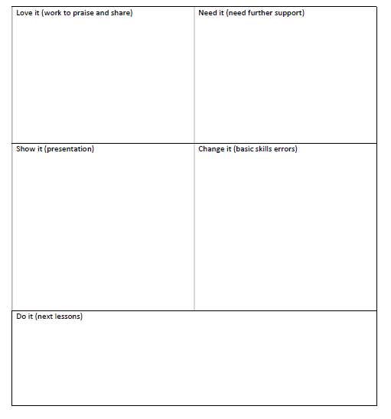**Appendix 2: Example whole class feedback grid**